**THE SUPERIOR COLLEGE LAHORE**

|  |
| --- |
|  |

**Faculty of Computer Science & IT**

**Department of Software Engineering**

**Final Year Project**

**PROJECT REPORT (Part-1)**

**[Zombie Rush]**

Project ID:**[ ]**

**Project Team**

|  |  |  |  |  |
| --- | --- | --- | --- | --- |
| **Student Name** | **Student ID** | **Program** | **Contact Number** | **Email Address** |
| Nabigh Saleem | BCSM-F16-174 | BSCS | 03100441097 | Nabigh.saleem1@gmail.com |
| Khawaja Nayab Ahmad | BCSM-F16-152 | BSCS | 03174431559 | Kna00p@gmail.com |
|  |  |  |  |  |
|  |  |  |  |  |
|  |  |  |  |  |

**[AsadUllah Tariq]**

([Lecturer])

**Project Report**

**[Zombie Rush]**

**Change Record**

|  |  |  |  |  |
| --- | --- | --- | --- | --- |
| **Author(s)** | **Version** | **Date** | **Notes** | **Supervisor’s Signature** |
|  | 1.0 |  | <Original Draft> |  |
|  |  |  | <Changes Based on Feedback from Supervisor> |  |
|  |  |  | <Changes Based on Feedback From Faculty> |  |
|  |  |  | <Added Project Plan> |  |
|  |  |  | <Changes Based on Feedback from Supervisor> |  |
|  |  |  |  |  |
|  |  |  |  |  |
|  |  |  |  |  |
|  |  |  |  |  |
|  |  |  |  |  |

**APPROVAL**

|  |  |
| --- | --- |
| **Project Supervisor** | |
| Comments: ___________________________________________________________________ | | |
| _____________________________________________________________________________ | | |
| Name:______________________________ |  | |
| Date:_______________________________ | Signature:__________________________ | |

|  |  |
| --- | --- |
| **Project Manager** | |
| Comments: ___________________________________________________________________ | |
| _____________________________________________________________________________ | |
|  |  |
| Date:_______________________________ | Signature:__________________________ |

|  |  |
| --- | --- |
| **Head of the Department** | |
| Comments: ___________________________________________________________________ | |
| _____________________________________________________________________________ | |
|  |  |
| Date:_______________________________ | Signature:__________________________ |

# Dedication

*This work is dedicated to my . . . . . .*

# Acknowledgements

I am really thankful to my supervisor who has . . . . . . . . . .

# Executive Summary

The Story depends on a human who is attempting to get by in the zombie end times. The story starts when a Meteor slammed on the outside of earth and caused an infection which came about into causing people to do anomalous exercises and at long last it transformed them into zombies. Presently following 10 years zombies have expanded radically and now there is a little segment of human culture who are unaffected from the infection they have made their spare base to shield them from the zombies. The objective of our primary character is to battle his way through rushes of zombies to arrive at its objective which is the human culture.

# Table of Contents

Dedication iv

Acknowledgements v

Executive Summary vi

Table of Contents vii

List of Figures ix

List of Tables x

Chapter 1 1

Introduction 1

1.1. Background 2

1.2. Motivations and Challenges 2

1.3. Goals and Objectives 2

1.4. Literature Review/Existing Solutions 2

1.5. Gap Analysis 2

1.6. Proposed Solution 2

1.7. Project Plan 3

1.7.1. Work Breakdown Structure 3

1.7.2. Roles & Responsibility Matrix 3

1.7.3. Gantt Chart 3

1.8. Report Outline 3

Chapter 2 4

Software Requirement Specifications 4

2.1. Introduction 5

2.1.1. Purpose 5

2.1.2. Document Conventions 5

2.1.3. Intended Audience and Reading Suggestions 5

2.1.4. Product Scope 5

2.1.5. References 6

2.2. Overall Description 6

2.2.1. Product Perspective 6

2.2.2. Product Functions 6

2.2.3. User Classes and Characteristics 6

2.2.4. Operating Environment 7

2.2.5. Design and Implementation Constraints 7

2.2.6. User Documentation 7

2.2.7. Assumptions and Dependencies 7

2.3. External Interface Requirements 8

2.3.1. User Interfaces 8

2.3.2. Hardware Interfaces 8

2.3.3. Software Interfaces 8

2.3.4. Communications Interfaces 9

2.4. System Features 9

2.4.1. System Feature 1 9

2.4.1.1. Description and Priority 9

2.4.1.2. Stimulus/Response Sequences 9

2.4.1.3. Functional Requirements 9

2.4.2. System Feature 2 10

2.4.2.1. Description and Priority 10

2.4.2.2. Stimulus/Response Sequences 10

2.4.2.3. Functional Requirements 10

2.4.3. System Feature 3 (and so on) 11

2.5. Other Nonfunctional Requirements 11

2.5.1. Performance Requirements 11

2.5.2. Safety Requirements 11

2.5.3. Security Requirements 12

2.5.4. Software Quality Attributes 12

2.5.5. Business Rules 12

2.6. Other Requirements 12

Chapter 3 13

Use Case Analysis 13

3.1. Use Case Model 14

3.2. Fully Dressed Use Cases 14

Chapter 4 15

System Design 15

4.1. Architecture Diagram 16

4.2. Domain Model 16

4.3. Entity Relationship Diagram with data dictionary 16

4.4. Class Diagram 17

4.5. Sequence / Collaboration Diagram 17

4.6. Operation contracts 17

4.7. Activity Diagram 18

4.8. State Transition Diagram 18

4.9. Component Diagram 18

4.10. Deployment Diagram 19

4.11. Data Flow diagram [only if structured approach is used - Level 0 and 1] 19

Chapter 5 20

Implementation 20

5.1. Important Flow Control/Pseudo codes 21

5.2. Components, Libraries, Web Services and stubs 21

5.3. Deployment Environment 21

5.4. Tools and Techniques 22

5.5. Best Practices / Coding Standards 22

5.6. Version Control 22

Appendices 23

Appendix A: Information / Promotional Material 24

Reference and Bibliography 27

Index 29

# List of Figures

2.1.1 Work Breakout Structure 5

2..1.2 RACI Matrix 6

2.1.3 Gantt Chart 6

1.3.4 Communication Interface 17

3.1 Use Case model 28

5.1 Caption of first figure of fifth chapter 49

5.2 Caption of second figure of fifth chapter 49

# List of Tables

1.1 label of first table of first chapter 6

1.2 label of second table of first chapter 7

2.1 label of first table of second chapter 14

2.2 label of second table of second chapter 22

2.3 label of third table of second chapter 26

5.1 label of first table of fifth chapter 49

5.2 label of second table of fifth chapter 49

# Chapter 1

# Introduction

**Chapter 1:** Introduction

It is a first-individual disconnected single-player shooter game. As far as interactivity, there will be one playable character, and assets, weapons, and haven will be accessible in further interactivity.

A story mode is presented in the game. A character is an average person attempting to endure the zombie end times. The objective of our fundamental character is to battle his way through influxes of zombies to arrive at its objective which is the remainder of enduring human culture.

## Background

These days, there are a not many games on zombies some depend on simply killing them and some depend on restoring; There is no addictive storyline to follow for the gamers. Some give great realistic yet dull story and some furnish terrible designs with great story.

We are making a game which will furnish great designs with inventive/secrets storyline, we will give an addictive storyline to the gamers so when they finish this part then they stand by frantically for the following one and when we will be finished with our game you will have a first class game which will be adored by everybody.

## Motivations and Challenges

Our Motivation for this undertaking is that since our youth we have played computer games like insane now we have build up some energy to build up our own game so one day we contemplated game beginning chipping away at it.

There will be a great deal of difficulties Nowadays, there are a not many games on zombies some depend on simply killing them and some depend on relieving; There is no addictive storyline to follow for the gamers. Some give great realistic however dull story and some give awful designs great story.

We are making a game which will give great designs imaginative/puzzles storyline, we will give an addictive storyline to the gamers so when they finish this part then they stand by urgently for the following one and when we will be finished with our game you will have a first rate game which will be adored by everybody.

Our Motivation for this task is that since our youth we have played computer games like insane now we have build up some energy to build up our own game so one day we contemplated game beginning dealing with it.

There will be a great deal of difficulties

in this task.Character Designing

* Map Designing
* Animation Effects
* Sound Effects
* User Interface
* Cinematic

## Goals and Objectives

Zombie Rush is a first-individual shooter disconnected single-player game planned for giving a fun and engaging player experience to gamers all around the globe. The game will at first delivery for Windows 64-piece on Steam.

The primary target of the game is to help individuals from all around the globe improve a portion of the aptitudes that will help them, in actuality, for example, endurance, better dynamic, improved perception, and quicker response time through our game. The game will likewise be the establishment of PC game advancement in Pakistan as most (if not the entirety) of the game improvement studios in the nation are restricted to portable game advancement as it were.

**Game will comprise of**

* First Person Perspective
* Guns and Ammunition
* Different Terrains and Locations
* Aliens and Wild creatures as Enemies/Target
* Different Difficulty Levels
* Health Bar
* Character Animation
* Sound Effects

## Literature Review/Existing Solutions

Zombie Rush itself is a new and unique idea and is not a follow-on of any game. There are many other games regarding zombies with different storylines, but this game is different with a unique storyline that has never been introduced in any games..

## Gap Analysis

Nowadays, it's such a dry market if we talk about good games. Games are not perfect, some have good graphics and some have good storyline. We need both at the same time. There's a lack of good quality game which is up to the mark in every aspect.

## Proposed Solution

We are making a game which will give excellent designs inventive/puzzles storyline, we will give an addictive storyline to the gamers so when they finish this part then they stand by frantically for the following one and when we will be finished with our game you will have a first rate game which will be cherished by everybody.

## Project Plan:

The Project Plan is described below in Gantt Chart, WBS and RRM.

## Work Breakdown Structure

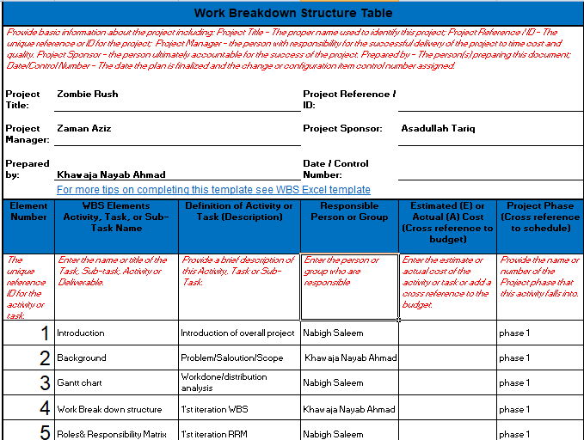

Work Breakdown Structure 1

## Roles & Responsibility Matrix

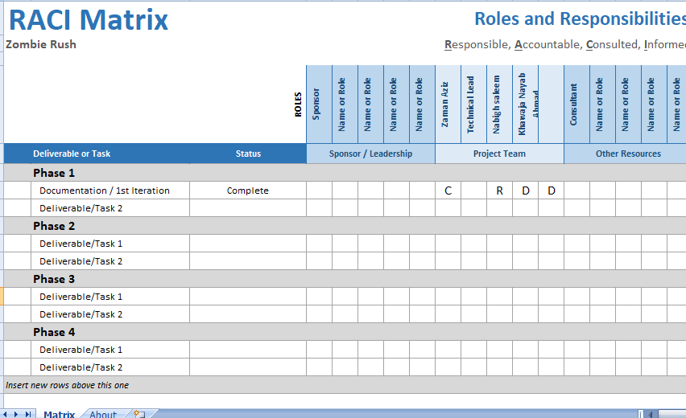

RACI Matrix 1

## Gantt Chart

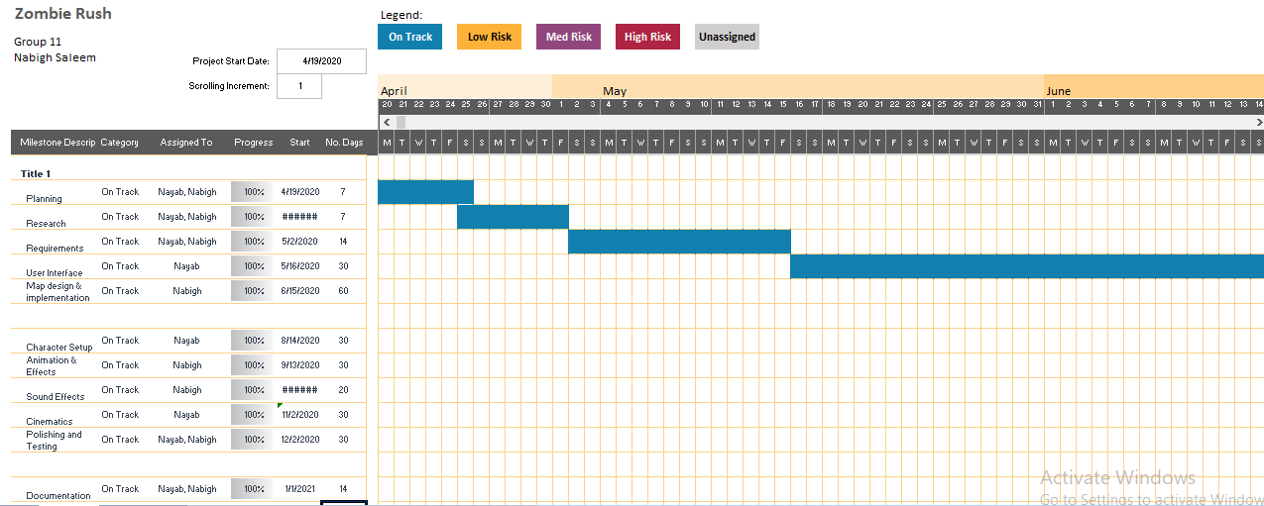

Gantt Chart 1

## Report Outline

[Paragraph Text 12 pt, Calibri, 1.5 Line Spacing, Justified]

Chapter 2

**Software Requirement Specifications**

**1.1. Introduction**

**1.1.1. Purpose**

This documentation gives the Product Necessity Determinations to the 3D computer game, "Zombie rush". It is a first-individual shooter disconnected single player game.

All parts of the game, including the game's inward working, UIs, working condition, highlights and necessities are canvassed in this archive.

**1.1.2. Document Shows**

Following shows are utilized for the documentation:

• **Font Style:** Times New Roman

• **Paragraph Text dimension:** 12

• **Sub-areas Headings Text dimension:** 14

• **Sections heading Text dimension:** 18

• **Bold Writings:** Utilized for headings, sub-headings and significant watchwords.

**1.1.3. Intended Crowd and Understanding Proposals**

This Product Asset Determination documentation is typical for the authorities of this game, analyzers and any avowed individual that may identify with the task in any capacity during its improvement life cycle. It can't be made accessible to open and end clients as it would bargain the security of the thing.

Inspects are expected to examine the report in the sales it is filtered through. The requesting for this document is sorted out in an advantageous manner with a definitive target that investigates don't need to bounce forward and in reverse in the record for real comprehension of it.

**1.1.4. Product Scope**

Zombie Rush is a first-singular shooter detached single player game made arrangements for giving a fun and connecting with player experience to gamers all around the world. The game will from the outset release for Windows 64-piece on Steam, yet reduced to Android, IOS, Macintosh working framework, PlayStation 4, Xbox One and Nintendo Switch.

The standard objective of the game is to help people from all around the world improve a part of their aptitudes that will support them, taking everything into account, for instance, perseverance, better powerful, improved discernment and snappier reaction time through our game. The game will moreover be the foundation of PC game improvement in Pakistan as most (if not the sum) of the game progression studios in the country are compelled to flexible game headway in a manner of speaking.

**1.1.5. References**

**1.2. Overall Description**

**1.2.1. Product Point of view**

Zombie Rush is another and astounding idea and is certainly not a resulting individual from any game. The game will have an intriguing fight structure using exceptional limits of the character. Its progression is made possible by the game improvement device Solidarity 3D which can total C# substance and develop games for use on the Windows stage.

**1.2.2. Product Capacities**

• Play Game

• Continue Game

• About

• Game Settings

**1.2.3. User Classes and Qualities**

Players of all ages and aptitude level ought to be effectively ready to get the pace. However,.as like in some other game, there is consistently a characteristic division between.casual.and hardcore.gamers. These two classes will normally differentiate.themselves using the game-play.mechanics and the structure of the game.

The capacities and attributes recognizing bad-to-the-bone players will include:

• Using of character capacities at correct time.

• High APM (Activities Every Moment).

• Good collaboration and coordination with powerless colleagues.

**1.2.4. Operating Condition**

Game will just help Windows 64-piece working framework on dispatch. Backing for other working frameworks can be included future if the interest ever emerges. Following are the framework's equipment determinations required to run the game:

**Minimum Requirements:**

• OS.:.Windows.7.64-Bit./.Windows.8.64-Bit./.Windows.8.1.64-Bit./.Windows.10.64-Bit

• Processor.:.Intel(R).Core(TM).i5-750.at.2.67.GHz.or.equivalent

• Memory.:.4.0 GB.of.RAM

• Graphics.:.NVIDIA.GeForce.GTX.470.at.1GB.or.ATI.Radeon.HD.6970.at.1GB

• DirectX.:.Version.11.0

• Hard.Drive.:.12.0 GB.of.free space

• Sound Card.:.DirectX. Compatible

**Suggested Determination:**

• OS.:.Windows.7.64-Bit./.Windows.8.64-Bit./.Windows.8.1.64-Bit./.Windows.10.64-Bit

• Processor: Intel(R).Core(TM).i5-3570.at.3.40.GHz.or.equivalent

• Memory.:.8.0 GB.of.RAM

• Graphics.:.nVIDIA.GeForce.GTX.750.Ti.at.2GB./.ATI.Radeon.HD.7870.at.2GB

• DirectX.:.Version.11.0

• Hard.Drive.:.12.0 GB.of.free space

• Sound.Card.:.DirectX.Compatible

**1.2.5. Design and Usage Requirements**

Following are the major constraints that are concerned with the game:

**• Hardware Limitations:**

Zombie Rush is an unquestionable PC game with first rate representations and uncommon perceptions. In case the gear running the game doesn't meet the foreordained necessities that are makes reference to above in territory 2.4 then the game will slack (FPS will be underneath 60) making the game not run effectively which will over the long haul lead to cause bottleneck and the game may crash.

**•Steam Specific:**

Zombie Rush is restricted to discharge on Steam just as it utilizes steams conveyance administration for discharging. Discharging the game on an alternate stage is conceivable yet should render the game as indicated by the norms of the predefined stage.

**1.2.6. User Documentation**

Game doesn't have any external helping substance, for instance, a customer manual or starter instructional exercise. There is a "Help" elective open in the game accessible through rule menu, which delineates all the fundamentals of game to outfit the customer with the basic idea of what the game is and how it will in general be played.

**1.2.7. Assumptions and Conditions**

Zombie Rush will be from the outset pushed for Windows 64-piece working system available on Steam (automated game flow stage). In any case, Solidarity will be all responsible.for both the progression of the game and its integration.within.the Windows structure. The headway of the game consolidates numerous verifiable part (assets) and modules which will quicken the strategy of the improvement overall.

Game have following conditions:

• Mid-go PC or PC with Realistic Card for advancement

• Unity Resource Store for downloading top notch resources

• Steam for discharging the game

• Internet for joining on Steam and downloading the game

• A PC meeting the predetermined necessities for playing the game

**1.3. External Interface Requirements**

**1.3.1. User Interfaces**

Zombie Rush involves the accompanying UIs:

• Intro

• Main Menu

• Settings

• About

• Help

• Pause Menu

**Introduction:**

The cinematics will be played after beginning the game remembering the logo of motor for which it is created for example Solidarity and a short time later the Logo of the game.

**Main Menu:**

This is the main screen that client sees when the game loads up. It gives access to Begin Game, Proceed with Game, Game settings and about choice.

**Settings:**

Gives an assortment of settings to the game, for example, illustrations, goals, sound and so on which the client can conform to improve the casing rate at which the game runs as per their equipment details.

**About:**

This alternative will be accessible in the principle menu which will portray the total story line of the game, about the character and how it will advance.

**Help:**

This alternative will be accessible in the game which portrays all the fundamentals of game to give the client the essential thought of what the game is and how it very well may be played.

**Pause Menu:**

The game can be stopped anyplace in the ongoing interaction for changing the game settings or spare the game at the current advancement.

**1.3.2. Hardware Interfaces**

Equipment Interfaces Game utilize 3 distinctive equipment gadgets to get contribution from client:

• Mouse

• Keyboard

• Xbox One Controller (Gamepad)

**Mouse:**

For exploring through menu and camera development in ongoing interaction.

**Keyboard:**

For exploring through menu and furthermore for player development and capacities, for example, development of the player, shooting, etc that are utilized during the ongoing interaction.

**Gamepad:**

For camera development, player development and capacities use in ongoing interaction. The gamepad is discretionary just for those players who are open to playing with a gamepad.

**1.3.3. Software Interfaces**

Zombie Rush is being created utilizing the accompanying rundown of game improvement devices.

Their description and purpose is discussed as follows:

**Unity (Game Motor):**

Unity.is a.cross-platform.gaming engine. It is made by Solidarity Innovations. The engine is prepared for creating.three-dimensional,.two-dimensional,.virtual reality, and expanded reality games,.as well.as amusement games and various experiences, for instance, film, building, etc. This is the essential part wherein the game is made.

**Visual.Studio.Code:**

Visual.Studio Code is source-code editorial manager created by Microsoft. This IDE has been utilized to compose and alter all the scripting in C# language identified with the game.

**Steam:**

Steam is the world's biggest advanced appropriation stage for games. They give their own online subsystem to games to coordinate their store highlights. Zombie Rush will utilize steam's online subsystem for discharging the game.

**1.3.4. Communications Interfaces**

So as to play the game the client must download it from steam by signing in his record. It ought to be introduced on a PC that meets the predefined necessities.

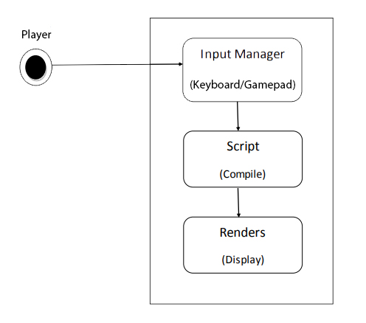

Communication Interface 1

The game is a disconnected story-mode so it doesn't have any online usefulness.

The player can cooperate with the game by providing input orders (press "**Enter**" key to begin the game) to the framework. The framework will provide those info orders to the backend contents, if any change will happen (if the condition is valid) this will send to render to show the items (the character changes its position).

**1.4. System Highlights**

• Title Screen

• Main Menu

• Start Game

• Settings

• About

• Exit

• Pause Menu

• Help

• Player

• NPC(Aliens)

• HUD(Heads Up Show)

**1.4.1. Title Screen:**

**Description:**

The title screen is the screen the player will see each time subsequent to running the game. It will consolidate the sprinkle screen of the improvement gadgets used in making the game. After that it will join the guideline logo of the game with an establishment as shown by the game point.

A message will be appeared on the screen mentioning that the customer press Enter key to start and it will go the essential menu screen.

**Reaction:**

• The player dispatches the game on the framework.

• The title screen stacks up and shows on the screen provoking the player to press "Enter"

**Response:**

• The player presses "Enter" key which triggers its capacity taking the player to the principle menu

**Functional Requirements**:

• The title screen must load up and show each time after propelling the game

• If the player presses the "Enter" key it ought to play out its capacity and burden the primary menu

• If the player finishes the game, the game will end restoring the player to the title screen

**2.4.2 - Main Menu :**

**Description:**

The essential menu will appear before the customer after the title screen in the wake of completing its significant necessities to complete that are pressing the Enter key in the title screen. It will show the choices of Start Game, Proceed Game,.Settings and Exit.

**Reaction:**

• The player presses Enter key from the title screen.

• The principle menu comes up showing the necessary alternatives

**Functional Requirements:**

• The principle menu should consistently come up after the title screen upon each time propelling the game

• The alternatives in the principle menu must show on the screen for the client to collaborate

• If the player begins any of the alternatives accessible on the fundamental menu their capacity must be performed

**2.4.3-Start Game:**

**Description:**

First choice accessible on the fundamental menu after squeezing it the game will begin.

**Reaction:**

• The player presses the beginning game choice by choosing it

• The game will load and start

**Functional Requirements**

• The game should consistently begin after squeezing the Beginning Game alternative

**2.4.4-Settings :**

**Description:**

Settings gives various choices to clients to change the illustrations, sound and ongoing interaction settings to guarantee better player experience just as smooth running of the game on various kinds of equipment.

Settings can be gotten to by heading off to the fundamental menu and tapping on the "Settings" button. Settings further partitions the accessible settings into four classifications: Designs, Sound and Ongoing interaction.

**Reaction:**

• The player presses the Settings alternative by choosing it from the fundamental menu

• The framework will open the settings menu that are accessible

**Functional Requirements:**

• The framework should consistently open the settings menu after squeezing the Settings alternative

• All the settings that are accessible must work and apply in the game

**2.4.5-About :**

**Description:**

The About alternative will give all the subtleties of the game. It will likewise recount to the story line of the game, some foundation of the player that is in the game and how to advance in it.

**Reaction:**

• The player presses the About alternative by choosing it from the primary menu

• The framework will open the About tab

**Functional Requirements:**

• The framework should consistently open the About tab after squeezing the About alternative

• All the subtleties of the game must be incorporated the alternative

**2.4.6-Exit :**

**Description:**

The Leave catch will leave the game and close it restoring the client to the work area.

**Reaction:**

• The player presses the Leave button by choosing it from the primary menu

• The framework will close the game

**Functional Requirements:**

• The framework should consistently leave the game at whatever point the catch is squeezed

**2.4.7-Pause Menu**

**Description:**

This is a huge factor that should be accessible because during progressing connection any endeavor can think about the player so an interference menu is noteworthy with the objective that the game will stop around at that point and can be proceeded with a brief timeframe later.

This menu will simply work during the continuous association to postpone the game in the wake of crushing the "Esc" key. It will quit all that will be going on the game and will open the relief menu which will join the options of Resume, Settings and Exit.Leave alternative will stop the game and return the player to the title screen.

**Reaction:**

• The player presses the Esc during interactivity to open the delay menu

• The choices accessible in delay menu are shown

• Resume choice continues the game restoring the player to the ongoing interaction.

• Settings choice opens the setting menu wherein the client can change the settings of the game

• Exit alternative stops the game and returns the player to the title screen.

**Functional Requirements:**

• The framework should consistently open the Delay Menu after squeezing its ideal key

• The game must be stopped so no further activity happens in the ongoing interaction

• The choices accessible in the delay menu work viably

• The game must resume so the player comes back to the ongoing interaction and play further

**2.4.8-Player**

**Description:**

The player is the key character of the game which the customer will control during continuous communication. As this is a FPS game so customer will consider the to be of the player as in detail the customer will see the arms of the player. All the turns of events and exercises of the player will be obliged by the customer depending upon their data key.

The player looks will be controlled from the Mouse and he will attack/shoot through crushing the left snap of the mouse.

Each and every other turn of events and exercises will be controlled from the Console with a couple of information keys for every limit.

**Reaction:**

• The player is available in the game after beginning it

• The control inputs communicate with the player and play out the function(moving forward)

**Functional Requirements:**

• The framework should consistently play out the procedure on the player when the client squeezes its key (after squeezing left snap of mouse the player must assault or shoot)

**1.5. Other Nonfunctional Requirements**

**1.5.1. Performance Requirenements**

To guarantee best player involvement in smooth interactivity and elite, after are the prescribed prerequisites to run the game at most extreme realistic settings with stable 60 casings for every second:

• OS.:.Windows.7.64-Bit./.Windows.8.64-Bit./.Windows.8.1.64-Bit./.Windows.10.64-Bit

• Processor: Intel(R).Core(TM).i5-3570.at.3.40.GHz.or.equivalent

• Memory.:.8.0 GB.of.RAM

• Graphics.:.NVIDIA.GeForce.GTX.750.Ti.at.2GB./.ATI.Radeon.HD.7870.at.2GB

• DirectX.:.Version.11.0

• Hard.Drive.:.12.0 GB.of.free space

• Sound.Card.:.DirectX.Compatible

**1.5.2. Safety Requirements**

Playing for postponed time can cause Computer.Vision.Syndrome, in which loss faces blurry.vision, eye.irritation, light.sensitivity, neck and shoulder torture.

Game shows dead creatures, untouchables, murders and use of guns, which may impact an individual if his/her mental state isn't consistent. It is a separated game which suggests player will stand up to outcasts creatures of different characters with upsetting appearances and living corpses which may cause the player to get weakened or mentally agitated at whatever point faced.

The customer is needed to take a break after as expected of industrious playing to hinder eye weakness and repetitive.strain injury. Regardless there are the same safety.requirements.

A couple of individuals are fragile to specific tints whose introduction may not be legitimate for them, so they should keep up a key good ways from or avoid any and all risks if possible considering the way that game doesn't have screen channels available for unequivocal shades or outwardly tested people.

**1.5.3. Security Requirements**

Uncommon username and mystery expression will be needed to get to player record of steam which will allow them to download the game. In purchasing the game and downloading it, Steam doesn't release any near and dear information of the customer as per security procedure.

To ensure the validness of game purchases, all organizations will be given by steam. This is just a prudent step to guarantee no unapproved trade occurs as someone may endeavor to modify the game records.

Beside the above given viewpoints there are no other express security and privacy.requirements.

**1.5.4. Software Quality Attributes**

To ensure enduring quality. likewise, rightness, game will respond to the player's data orders in an ideal manner without structure slack. For adaptability, the Graphical.User.Interface will be amazingly natural for the player to use, and moreover game will save the player's progression. That way, if the customer needs to murder the game he will have his progression saved.

Zomibe Rush is a game that any player can present and play in a brief moment without consuming a lot of time endeavoring to comprehend the controls and how to play it.

**1.5.5. Business Principles**

Game will have just single job that is of player. Each client is a player of the game and has same access to all the game substance as some other player.

# Chapter 3

# System Analysis

**Chapter 3:** System Analysis

This Chapter includes **Use Case** models and **Fully Dressed Use Cases**

## Use Case Model

* + 1. **Run Application:**

The user will run the Application by opening the executable file of the game and the game will run.

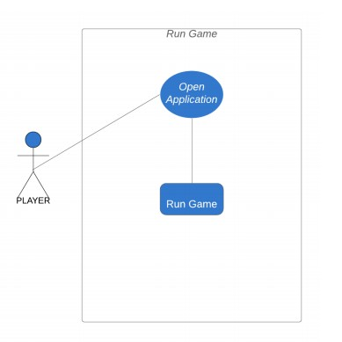

Run Application 1

* + 1. **Main Menu:**

This is the main screen that client sees when the game loads up. It gives admittance to Play Game, , Options and Exit.

To Play the game just snap on the Play catch and it will stack the following scene. For Mode essentially click on button and the game will stack the scene. To change settings go to the Options button. To Exit the game snap on the Exit button.

3.1.3. **Player:**

The in game player can play out all the capacities accessible in the outline.

This outline portrays all the developments and activities the player can perform. Look is constrained by the mouse which glances around in the game. The player can push ahead, in reverse, both ways. The player can Aim and Shoot or essentially shoot. The player can hop, hunker and run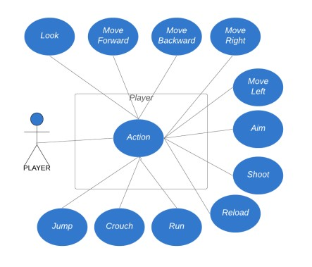

Player 1

* + 1. **Inventory:**

Any item which is an inventory item can be picked up by the player which will be added to the inventory. The player can use it, drop it or bind a shortcut key to it. Any inventory that the player picks up adds up in the inventory tab where he can view the item. When an item is added in the inventory the player can either use the item, drop the item and if it is a weapon a shortcut key can be bind to it

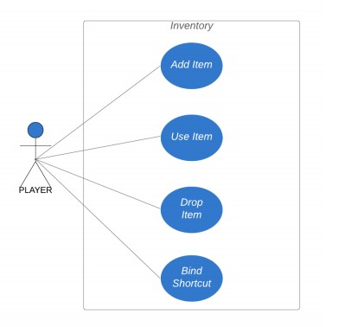

Inventory 1

* + 1. **Weapon System:**

The player will find weapons in the game he can pick them up which will add up to the inventory or drop a weapon

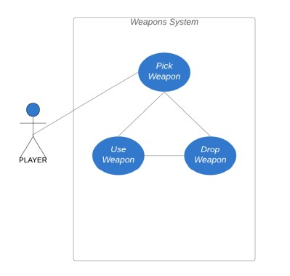

Weapon System 1

* + 1. **Options:**

Settings gives numerous choices to clients to modify the designs, sound and interactivity settings to guarantee better player experience just as smooth running of the game on various kinds of equipment settings can be gotten to by heading off to the fundamental menu and tapping on the "Choices" button. Settings further partitions the accessible settings into three classifications: General, Graphics and Controls.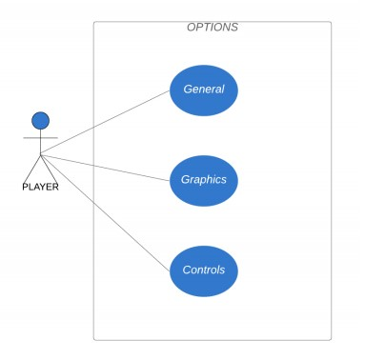

Option 1

* + 1. **Exit:**

The Exit button will be used to exit the game from the Main Menu. To exit simply click on the exit button The user clicks on the Exit button from the Main Menu and the application exits

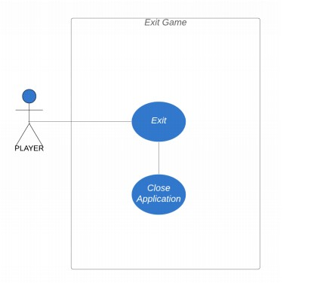

Exit Game 1

## Fully Dressed Use Cases

* + 1. **Run Game:**

|  |  |  |  |
| --- | --- | --- | --- |
| **Use Case Number:** | UC-1 | | |
| **Title:** | Run Game | | |
| **Created By:** | Nabigh Saleem  Khawaja Nayab | **Edited By:** |  |
| **Date Created:** | 13/06/2020 | **Date Edited:** | 13/06/2020 |
| **Actors:** | Player(Character) | | |
| **Summary:** | The user will run the Application by opening the executable file of the game and the game will run. | | |
| **Trigger:** | The player need to start new game | | |
| **Preconditions:** | Game is installed on the computer  Game is working. | | |
| **Normal Flow:** | 1. Go to the main Menu of the game;  2. Click play game button.  3. New game loaded on system. | | |
| **Alternative Flows:** | None | | |
| **Exceptions:** | Game Crashed | | |

* + 1. **Main Menu:**

|  |  |  |  |
| --- | --- | --- | --- |
| **Use Case Number:** | UC-2 | | |
| **Title:** | Main Menu | | |
| **Created By:** | Nabigh Saleem  Khawaja Nayab | **Edited By:** |  |
| **Date Created:** | 13/06/2020 | **Date Edited:** | 13/06/2020 |
| **Actors:** | Player(Character) | | |
| **Summary:** | To go to the Main Menu | | |
| **Trigger:** | The player need to start new game | | |
| **Preconditions:** | Game is installed on the computer  Game is working. | | |
| **Normal Flow:** | 1. Go to the main Menu of the game;  2. Click play game button.  3. New game loaded on system. | | |
| **Alternative Flows:** | None | | |
| **Exceptions:** | Game Crashed | | |

* + 1. **:**

|  |  |  |  |
| --- | --- | --- | --- |
| **Use Case Number:** | UC-3 | | |
| **Title:** |  | | |
| **Created By:** | Nabigh Saleem  Khawaja Nayab | **Edited By:** |  |
| **Date Created:** | 13/06/2020 | **Date Edited:** | 13/06/2020 |
| **Actors:** | Player(Character) | | |
| **Summary:** | is a mode to test in-game items. Users can test any in-game item in this mode to ensure the controls and gameplay of the player. | | |
| **Trigger:** | The player need to select the Mode | | |
| **Preconditions:** | Game is installed on the computer  Game is working. | | |
| **Normal Flow:** | 1. Go to the main Menu of the game;  2. Click Mode button.  3. Mode will be loaded on system. | | |
| **Alternative Flows:** | None | | |
| **Exceptions:** | Game Crashed | | |

* + 1. **Player:**

|  |  |  |  |
| --- | --- | --- | --- |
| **Use Case Number:** | UC-4 | | |
| **Title:** | Player | | |
| **Created By:** | Nabigh Saleem  Khawaja Nayab | **Edited By:** |  |
| **Date Created:** | 13/06/2020 | **Date Edited:** | 13/06/2020 |
| **Actors:** | Player(Character) | | |
| **Summary:** | The player can move forward, backward, right and left. The player can Aim and Shoot or simply shoot. The player can jump, crouch and run. | | |
| **Trigger:** | Pressing buttons and giving commands from the keyboard. | | |
| **Preconditions:** | Game is installed on the computer  Game is working. | | |
| **Normal Flow:** | While playing the game, the character perform the actions when the respected buttons for those actions is pressed e.g Jump, crouch, run, aim and shoot. | | |
| **Alternative Flows:** | None | | |
| **Exceptions:** | Player is not responding to the commands  Game Crashed | | |

* + 1. **Options:**

|  |  |  |  |
| --- | --- | --- | --- |
| **Use Case Number:** | UC-5 | | |
| **Title:** | Options | | |
| **Created By:** | Nabigh Saleem  Khawaja Nayab | **Edited By:** |  |
| **Date Created:** | 13/06/2020 | **Date Edited:** | 13/06/2020 |
| **Actors:** | Player(Character) | | |
| **Summary:** | To load options in setting module. | | |
| **Trigger:** | Player Need to tap options button in the menu. | | |
| **Preconditions:** | Game is installed on the computer  Game is working. | | |
| **Normal Flow:** | 1. Press options button in menu  2. Options for setting menu opens up. | | |
| **Alternative Flows:** | None | | |
| **Exceptions:** | Game Crashed | | |

* + 1. **Inventory:**

|  |  |  |  |
| --- | --- | --- | --- |
| **Use Case Number:** | UC-6 | | |
| **Title:** | Inventory | | |
| **Created By:** | Nabigh Saleem  Khawaja Nayab | **Edited By:** |  |
| **Date Created:** | 13/06/2020 | **Date Edited:** | 13/06/2020 |
| **Actors:** | Player(Character) | | |
| **Summary:** | Any item which is an inventory item can be picked up by the player which will be added to the inventory. The player can use it, drop it or bind a shortcut key to it. | | |
| **Trigger:** | The player need to press the inventory button | | |
| **Preconditions:** | Game is installed on the computer  Game is working. | | |
| **Normal Flow:** | 1. Press the Inventory button in the game;  2. Inventory will open up. | | |
| **Alternative Flows:** | None | | |
| **Exceptions:** | Inventory will not open.  Game crashed | | |

**3.2.7 Weapon System:**

|  |  |  |  |
| --- | --- | --- | --- |
| **Use Case Number:** | UC-7 | | |
| **Title:** | Weapon System | | |
| **Created By:** | Nabigh Saleem  Khawaja Nayab | **Edited By:** |  |
| **Date Created:** | 13/06/2020 | **Date Edited:** | 13/06/2020 |
| **Actors:** | Player(Character) | | |
| **Summary:** | The player will find weapons in the game  he can pick them up which will add up to the inventory or drop a weapon. | | |
| **Trigger:** | When a weapon is found. Press the Pick up Option. | | |
| **Preconditions:** | Game is installed on the computer  Game is working. | | |
| **Normal Flow:** | ‘Pick Up’ option is selected when new weapon is found.  Weapon will be add in the inventory.  Weapon will be drop if ‘ Drop’ option is selected | | |
| **Alternative Flows:** | None | | |
| **Exceptions:** | Player couldn’t Add or Drop the Weapon  Game Crashed | | |

**3.2.8 Exit:**

|  |  |  |  |
| --- | --- | --- | --- |
| **Use Case Number:** | UC-8 | | |
| **Title:** | Exit Game | | |
| **Created By:** | Nabigh Saleem  Khawaja Nayab | **Edited By:** |  |
| **Date Created:** | 13/06/2020 | **Date Edited:** | 13/06/2020 |
| **Actors:** | Player(Character) | | |
| **Summary:** | To exit game | | |
| **Trigger:** | Need to tap exit button | | |
| **Preconditions:** | Game is installed on the computer  Game is working. | | |
| **Normal Flow:** | 1. Go to the main Menu of the game.  2. Click the exit button.  3. Game shut down. | | |
| **Alternative Flows:** | None | | |
| **Exceptions:** | Player couldn’t Exit.  Game Crashed | | |